AirNow

Air Quality Monitors Collect Ozone and Particle Pollution Data
AirNow Converts Data to the Air Quality Index (AQI)

The Air Quality Index and You
Green
Good
0 to 50
Colors
Levelsof HealthConcern
AirQualityIndex (AQI)Values
51-100
Moderate
Yellow
101-150
Unhealthy for Sensitive Groups
Orange
151-200
Unhealthy
Red
201-300
Very Unhealthy
Purple

301 to 500
Hazardous
Maroon

- Excercise away from busy roads
- Choose less strenuous activities
- Exercise for less time
- Be active outdoors when air quality is better

Take Action!

When the AQI is Orange or Above
Over 3,000 state and local monitors transfer data hourly for over 450 cities

AirNow.gov

Get the AQI

Who Should Use the AQI?

Everyone’s heart and lungs can be harmed by unhealthy air.
Those most at risk are:
  - People with heart or lung disease
  - People active outdoors
  - Older adults
  - Children
  - Outdoor workers

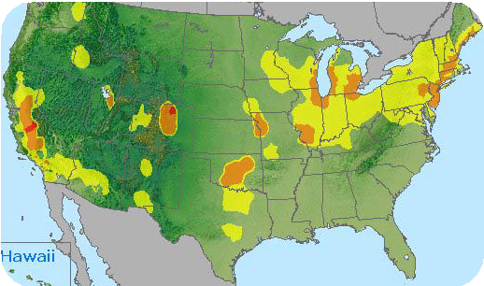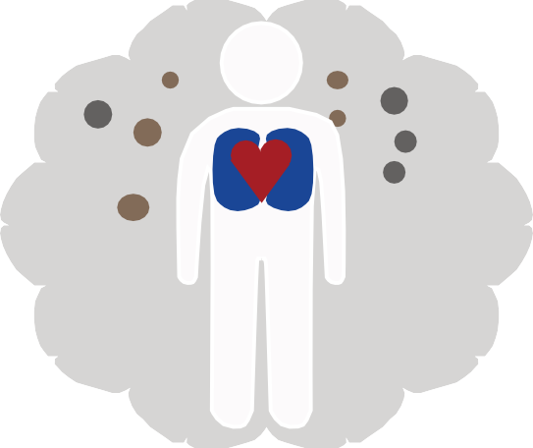

- Carpool, use public transportation, bike or walk
- Don’t spill fuel at the gas station
- Reduce energy use
Go to AirNow.gov to get:
  - Your local AQI
  - The AirNow app
  - The AirNow widget
  - EnviroFlash emails
Or check your local weathercast

