BE AIR AWARE

Do Something!

50 Actions You Can Take for Cleaner Air

Do your share. In Central Texas our principle air quality problem is the formation of ozone. It irritates our lungs and eyes, gives us headaches, and can even damage plants and crops. Ozone is not directly emitted, it is formed from a photochemical reaction when nitrogen oxides (NO_{x}) and volatile organic compounds (VOCs) combine and “cook” in the sun. Man-made sources of NO_{x} include internal combustion engines, electric generation units, and industrial facilities. VOC emissions come from many everyday activities such as painting, dry cleaning and pumping gas.

Some ozone exists at all times, but it can reach unhealthy levels under certain conditions (hot, sunny days with little wind). These days are often predictable and warnings are sent out, so Be Air Aware and sign up to get the warnings. Then Do Something special to reduce the emissions you cause on those days, and every day!

This guide offers 50 actions for reducing air pollution in our daily lives. Many of the solutions to air pollution can be put into two main categories:

Drive less. On-road vehicles account for as much as 1/2 of the air pollution created in Central Texas

Conserve Resources. The production of electricity, used for air conditioning and delivering potable water, is a significant contributor of the locally created air pollution. Buy Energy Star and WaterSense appliances.

Central Texas Clean Air Coalition AirCentralTexas.org
Be Air Aware
Do Something! … in your car.

- Drive Less. On-road vehicles account for almost half of the air pollution in Central Texas.
- Drive Light. Remove unneeded heavy objects from you vehicle
- Check your tires. Low tire pressure increases road friction and can waste up to 5% of a tank of gas.
- Get a tune up. Perform all maintenance according to the manufacturer’s schedule. A poorly tuned engine wastes 10-20% of the fuel it uses.
- Change your oil and air filters. Dirty oil and clogged filters can cause a 10% increase in fuel consumption.
- Stop at the click. When the gas pump clicks your fuel tank is full. Overfilling releases fumes into the air.
- Seal your tank. Closing your gas tank tightly - till the cap clicks - prevents gas from evaporating.
- Refuel after 6 p.m. Fueling your tank in cooler temperatures means less formation of ozone.
- Buy green, drive clean. Purchasing a cleaner burning, more fuel-efficient car produces less air pollution and saves you money on gas.
- Combine errands. Plan ahead to accomplish lots of errands in one trip. You’ll reduce your car trips and save gas and time.

Central Texas Clean Air Coalition AirCentralTexas.org

- Track your gas mileage. Sudden changes in your gas mileage can signal needed maintenance. Fix engine problems early to save money and travel safely.
- Take the bus. Relax and let someone else drive.
- Carpool or vanpool. Sharing rides can cut commuting costs in half or more.
- Ride your bike. It is cheaper and cleaner than riding in a car.
- Walk. It’s free!
- Avoid congestion. Driving during off-peak times can make your commute smoother and faster.
- Slow down. At high speeds you burn more fuel for each mile you drive.
- Don’t idle your engine. Idling wastes gas and produces unnecessary air pollution. This includes in the drive-thru.
- Bank by phone or internet. It will save you the trip and the gas money.
- Know before you go. Prior to leaving home check your directions to avoid congestion if possible.
- Drive smoothly. Avoid jackrabbit starts, which use up to 50% more gas than a smooth, gradual acceleration.

You are not stuck in the traffic, you are the traffic!
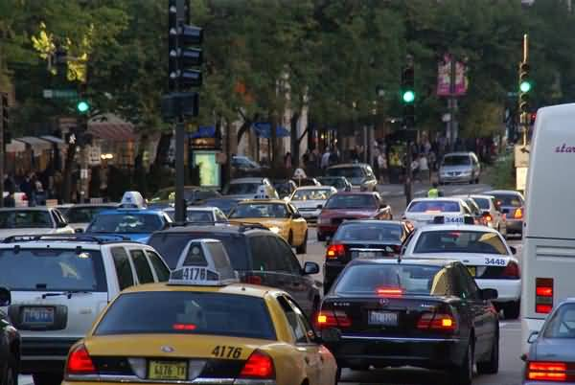

Central Texas Clean Air Coalition AirCentralTexas.org
Be Air Aware
Do Something! … at home.

- Save energy. When we use less energy, power plants burn fewer fossil fuels and release fewer chemicals that form ozone.
- Avoid ‘phantom loads’. Many appliances still use electricity when “off”. Examples: televisions, radios, computers, video game consoles all should be unplugged when not in use.
- Go fluorescent or LED. Switch to Energy Star light bulbs, especially in porch lights and other fixtures that stay on longer.
- Maintain your home. Save energy with proper insulation and ductwork.
- Set your thermostats. Save even more by keeping thermostats at or above 78 degrees in the summer and below 68 degrees in the winter.
- Save water. It takes a lot of energy to produce potable water and pump it to your home. Install low-flow shower heads and toilets. Check for water leaks.
- Use an electric or a push lawnmower. Mowing with a gas-powered mower for just one hour can produce as much pollution as driving your car 100 miles.
- Choose low-VOC paints. Volatile organic compounds (VOCS) are a precursor to ozone. You help the air when you choose alternatives to high VOC producing products.
- Grown green. Reduce year-round water consumption by xeriscaping your yard.
- Water better. Only water very early or late in the day. Have your irrigation system examined and tested. Check for leaks and install a smart controller and rain switch.

Central Texas Clean Air Coalition AirCentralTexas.org

- Lighten up. When it’s time to replace your roof, choose light-colored, reflective roofing materials. It can reduce your energy consumption by 40%.
- Plant more trees. They reduce the temperature of the surrounding air, provide shade, and absorb solar energy.
- Avoid lighter fluid. Try an electric or chimney style starter to get your charcoals glowing on the grill.
- Go solar. Consider concentrated solar for your water heater, and photovoltaic panels for the whole house.

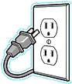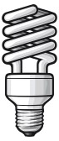

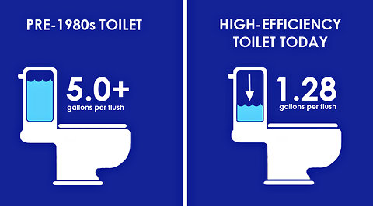

Central Texas Clean Air Coalition AirCentralTexas.org
Be Air Aware
Do Something! … at the office.

- Telecommute. Working from home can save you a trip.
- Teleconference. Holding meetings by phone or video saves you a trip.
- Work an alternative schedule. Flexible hours let you shift your commute to out of peak driving times and avoid traffic.
- Set convenient meeting locations. Choose meeting locations so that all attendees drive the shortest distance possible.
- Carpool to meetings. Save gas by sharing a ride.
- Walk to, or brown bag, your lunch. Avoid driving during the day.
- Use less paper. Make double-sided copies whenever you can.
- Let your computer sleep. Set the sleep function on your computer and turn off the monitor when you’re away from your desk.
- Cash in. Take advantage of business incentives to reduce ozone-forming emissions.

Central Texas Clean Air Coalition AirCentralTexas.org
Be Air Aware
Do Something! … to clear the air.

- Be Aware of ozone action day alerts in your favorite weather report. Do Something special on high ozone days.
- Talk. Spread the word to friends and family about what they can do to help prevent ground-level ozone.
- Break your routine. Be willing to Do Something better for the air, every day.
- Be a role model. Help a coworker find a bus route, or pass along a helpful phone number or website.
- Pitch in. The more healthy air choices you make, the sooner we can all breathe easy.
- Make a difference. Be Air Aware, individual choices add up to impact our future.

To see what is being done locally:
Air Central Texas.org
CleanAirForce.org

To see today’s air quality forecast:
tceq.texas.gov/airquality/monops/forecast_today.html
Airnow.gov/

To receive air quality updates by e-mail and text:
service.govdelivery.com/accounts/TXTCEQ/subscriber/new

For help with car pools and other commuting:
mycommutesolutions.com

For local traffic conditions:
google.com/maps/@30.4173053,-97.7695556,10z/data=!5m1!1e1

Central Texas Clean Air Coalition AirCentralTexas.org

Central Texas Clean Air Coalition AirCentralTexas.org

